CodeTutor Hackathon Plan
Nov 7, 2026 · @Ly

Overview
CodeTutor turns pasted code or a programming concept into a narrated, animated video lesson in the browser. Four people, 24 hours, one rule: one ugly lesson must play end to end by hour 10. Everything after that is polish.
The pipeline is: Planner → Script writer → Checker → TTS → Remotion Player. Videos play live in the browser with Remotion's Player, so there is no MP4 render server, no job queue and no database.
Must-haves (the demo): input page, AI lesson JSON, narration, highlighted code, title and recap cards, captions, transcript and chapters.
Stretch (only after the hour-10 checkpoint): practice problem + AI grading, 2 diagram templates, Explain simpler / Go deeper, MP4 download, follow-up chat.

Sponsors
Two sponsors are built into the core product and the rest are cheap extras. Using two sponsors properly beats name-dropping five, so each one has a clear job and an owner.
Sponsor | How we use it | Owner
ElevenLabs | Narrator voice (TTS). Its timestamps endpoint returns when each word is spoken, so captions and highlights sync to the voice. | D (and C for timing)
Featherless | The LLM behind the Planner, Script writer and Checker. OpenAI-compatible, so use the openai npm package with the Featherless base URL. Pick a large model. | B
Figma | Mock up the input and lesson pages before coding; show the designs in the pitch. | A
Freebuff | Free AI coding agent; use it while coding if its prize rewards that. | Everyone
n8n | Stretch only: run Planner → Writer → Checker → TTS as an n8n workflow, after the hour-10 checkpoint. | B or D
Skipping: Databricks (we already have an LLM), Lovable (we already have a codebase), RBC GAM and Investly (finance, not a fit). Deepspace and Maritime Labs: check their channels for what they offer.
Prize checklist: read each sponsor channel for its prize rules and free hackathon credits, name the sponsors out loud in the pitch, and tag every sponsor used on Devpost (submit to each sponsor track separately).

Timeline at a glance
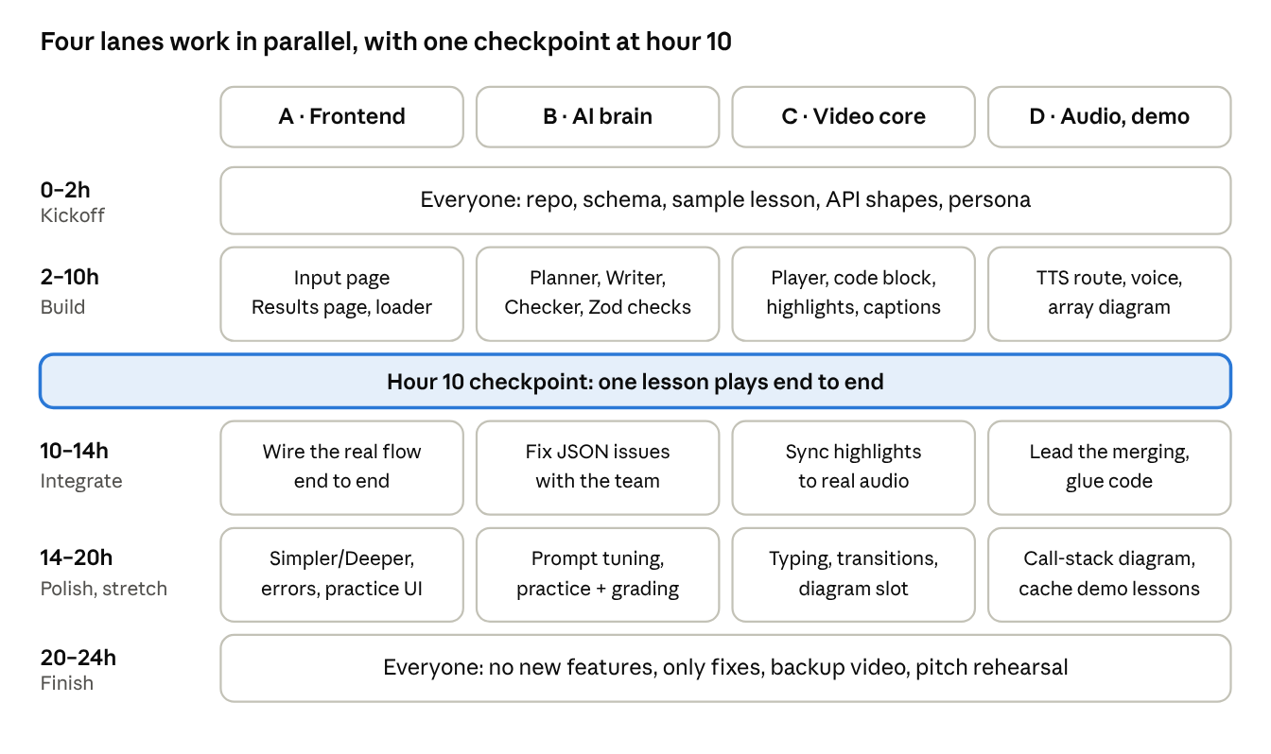
24h plan · 4 people, 5 phases, 1 checkpoint
Each person builds their own lane against the sample lesson, then the lanes meet at the hour-10 checkpoint.

Hour 0–2: everyone together
The first two hours decide whether the next eight run in parallel. Nobody writes feature code until these are agreed and committed.
- ☐ Create the repo: Next.js + TypeScript + Tailwind, add Remotion and @remotion/player, push to GitHub, everyone clones and runs it
- ☐ Add API keys to .env.local (Featherless + ElevenLabs keys), never commit it; share keys privately
- ☐ Lesson JSON schema written in lib/schema.ts (Zod), plus one hand-written sample lesson in mocks/sample-lesson.json
- ☐ API route shapes agreed: POST /api/lesson, POST /api/tts, POST /api/practice, POST /api/grade
- ☐ Diagram data shape agreed, e.g. { type: "array", values: [3, 1, 4], highlight: [1] }
- ☐ Teacher persona: an original name and one ElevenLabs voice
- ☐ Pick the integrator (A or D) who merges branches from hour 10
Folder ownership (fewer merge conflicts):
Folder | Owner
app/, components/ui/ | A
lib/ai/, app/api/lesson, app/api/practice, app/api/grade | B
remotion/ | C
lib/tts/, app/api/tts, remotion/diagrams/, mocks/ | D
lib/schema.ts | Everyone (change only after telling the team)

Person A: Frontend
A owns everything the user sees outside the video. Build against mocks/sample-lesson.json until B's API is live.
Hours | Task | Done when
2–5 | Input page: text area, language dropdown, mode selector, difficulty toggle, Generate button | Form submits and logs a valid request object
5–8 | Results page layout: player slot (C's Player), chapters list from scenes, transcript below | Sample lesson shows chapters and transcript; clicking a chapter seeks the player
8–10 | Pipeline loading screen: Planning → Writing → Checking → Recording → Ready | Steps advance as the real API calls finish
10–14 | Wire the real flow end to end with B and D | Typing "what is recursion?" ends on a playing lesson
14–18 | Explain simpler / Go deeper buttons, history in localStorage, error states (empty input, too long, API failed) | Each error shows a friendly message, never a blank page
18–20 | Practice-problem UI: show problem, answer box, feedback from /api/grade | Feedback appears under the answer
20–24 | Dark theme polish, mobile check on a real phone, bug fixes | Demo flow works on laptop and phone
Tips: mock up both pages in Figma first (it doubles as a Figma sponsor entry). Use Tailwind's dark palette from the start, not at the end. Cap input at around 4,000 characters in the form so huge pastes never reach the API.

Person B: AI brain
B owns the quality of the teaching, which is what judges actually remember. Lesson output must always match lib/schema.ts.
Hours | Task | Done when
2–4 | /api/lesson returns the mock JSON, then one real Featherless call with structured output | Route returns schema-valid JSON for "what is recursion?"
4–7 | Split into 3 steps: Planner (outline), Script writer (scenes), Checker (does narration match the code and highlighted lines?) | Each step logs its output; Checker can reject and trigger one rewrite
7–10 | Zod validation + 1 retry on bad JSON, input limits, clear error messages | Garbage input returns a friendly error, never a crash
10–14 | Integration with A and D | Real lessons play in the Player
14–18 | Prompt tuning: test 10 inputs (recursion, closures, loops, two-sum, a buggy snippet), fix tone, length, line accuracy | 8 of 10 lessons are good enough to show judges
18–20 | Simpler / Deeper flag, /api/practice and /api/grade | A practice problem is generated and graded
20–24 | Fill diagram data for D's templates where it fits; bug fixes | Recursion lesson includes a call-stack diagram
Teaching rules for the prompt: short sentences, one analogy, explain why not just what, walk the code line by line, show example input and output, end with a recap and one common mistake. Target 6–10 scenes, 1–3 minutes total.

Person C: Video core
C turns a lesson JSON into the animated video. Everything lives in remotion/ and is driven only by the schema, never by hard-coded text.
Hours | Task | Done when
2–4 | Remotion hello world inside Next.js: <Player> on a test page, one composition, a fade-in title | A title fades in on the test page
4–7 | Code block scene with Shiki syntax highlighting; highlight lines from highlightLines | Sample scene shows highlighted code, one line glowing
7–10 | Scene sequencing: each scene's length from its duration, title card first, recap card last; captions from narration | Whole sample lesson plays start to finish with captions
10–14 | Use real audio from D: play each scene's audio, scene length = audio length, split highlight time evenly across lines | Highlight moves in step with the voice
14–18 | Typing animation for new code, smooth transitions, slot for D's diagrams | Diagrams appear when a scene has diagram data
18–24 | Visual polish (fonts, spacing, colours that fit the dark UI), performance check on a phone, bug fixes | No stutter on a phone; looks like a tutorial channel
Tips: keep it 1280×720 at 30 fps. Start with even highlight timing. Once D returns ElevenLabs word timestamps, use them for word-synced captions; that is our best sponsor demo moment.

Person D: Audio, diagrams & demo
D owns the voice, the extra visuals, and making sure the demo cannot fail in front of judges.
Hours | Task | Done when
2–4 | One ElevenLabs call working: text in, audio file out, playing in the browser; pick the persona's voice | One sentence plays in the persona's voice
4–7 | /api/tts: all scenes in parallel, return audio URL + duration (seconds) per scene, plus word timestamps from ElevenLabs | 8 scenes come back in under ~15 seconds with durations
7–10 | Diagram template 1: array boxes (values, highlighted index) as a Remotion component | Renders from { type: "array", ... } data
10–14 | Integration lead with A: merge branches, fix glue code | Hour-10 checkpoint passes
14–17 | Diagram template 2: variables / call stack panel | Recursion lesson shows frames stacking up
17–20 | Cache 3–4 great demo lessons (JSON + audio) loadable without any API call; pitch slides | Demo works with Wi-Fi off
20–24 | Record a backup demo video, run pitch rehearsals with the team | Backup video saved on two laptops
Tips: use ElevenLabs' with-timestamps endpoint so C gets word timings. Keep each scene's narration under ~4,000 characters so it fits one TTS call. If TTS fails for one scene, retry that scene only.

Before the event and during it
Prep only what the hackathon rules allow; some events require all code to be written on the day.
Before the event (about 1 hour each):
- ☐ Everyone: Node.js installed, GitHub access, can run a fresh Next.js app
- ☐ A: skim Tailwind dark-mode docs
- ☐ B: get one Featherless call returning JSON from a script
- ☐ C: follow Remotion's getting-started and make a fade-in
- ☐ D: get one ElevenLabs clip playing; claim Featherless and ElevenLabs hackathon credits and set spending limits
- ☐ Read the hackathon rules: judging criteria, sponsor prize rules, pre-written code policy
During the event:
- 5-minute standing check-in every 4 hours: done, next, blocked
- Sleep in shifts so two people are always awake
- After hour 10, new features only if the checkpoint has passed
- Keep sponsor use visible: credit Featherless and ElevenLabs in the pitch and on Devpost
- From hour 20, no new features at all; only fixes and the pitch
Open questions: who presents the pitch, and whether Deepspace or Maritime Labs fit. Decided: Featherless for the LLM, ElevenLabs for TTS.

